Machine Learning Homework 1

Question 1)

a)

Given the table, we are asked to evaluate $P(Z| X = 0, Y = 0)$. If we look at the conditions where X and Y are 0, we see that Z can take 1 or 2 values with

$$P(Z=1| X = 0, Y = 0)=\frac{0.06}{0.06+0.09}=0.4$$

$$P(Z=2| X = 0, Y = 0)=\frac{0.06}{0.06+0.09}=0.6$$

Which provides the probability mass function of Z

b)

To check whether Y and Z are independent, we firstly integrate over X to get $P(Y,Z)$

|  |  |  |  |
| --- | --- | --- | --- |
| Z\Y | -1 | 0 | 1 |
| 1 | 0.12 | 0.08 | 0.1 |
| 2 | 0.33 | 0.17 | 0.2 |

Also integrate over Z on $P(Y,Z)$ to get $P(Y)$

|  |  |  |  |
| --- | --- | --- | --- |
| Y | -1 | 0 | 1 |
|  | 0.45 | 0.25 | 0.3 |

Lastly, integrate over Y on $P(Y,Z)$ to get $P(Z)$

|  |  |  |
| --- | --- | --- |
| Z | 1 | 2 |
|  | 0.3 | 0.7 |

For independence we need $P\left(Y,Z\right)=P(Y)P(Z)$ to hold.

$P(Y)P(Z)$ can be calculated as product of individual elements which is

|  |  |  |  |
| --- | --- | --- | --- |
| Z\Y | -1 | 0 | 1 |
| 1 | 0.135 | 0.075 | 0.09 |
| 2 | 0.315 | 0.175 | 0.21 |

Which is not the same as $P\left(Y,Z\right)$ *,* thus, we can conclude these normal variables are not independent

Question 2)

a)

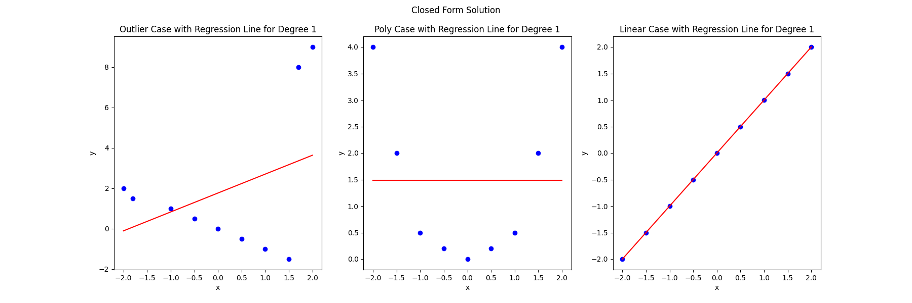

Figure : Closed form solution for linear regression

The expected absolute error for the Outlier data using closed_form and degree 1 is 2.9062

The expected absolute error for the Poly data using closed_form and degree 1 is 1.3432

The expected absolute error for the Linear data using closed_form and degree 1 is 1.4815

b)

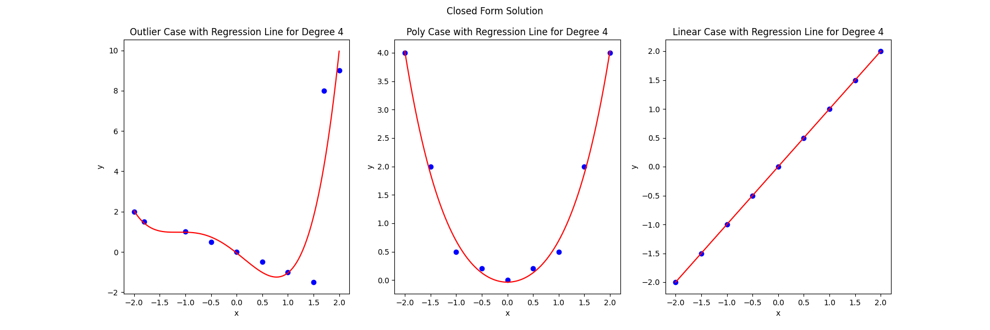

Figure : Closed form solution for fourth order polynomial

The expected absolute error for the Outlier data using closed_form and degree 4 is 3.3262

The expected absolute error for the Poly data using closed_form and degree 4 is 1.6297

The expected absolute error for the Linear data using closed_form and degree 4 is 1.4815

c)

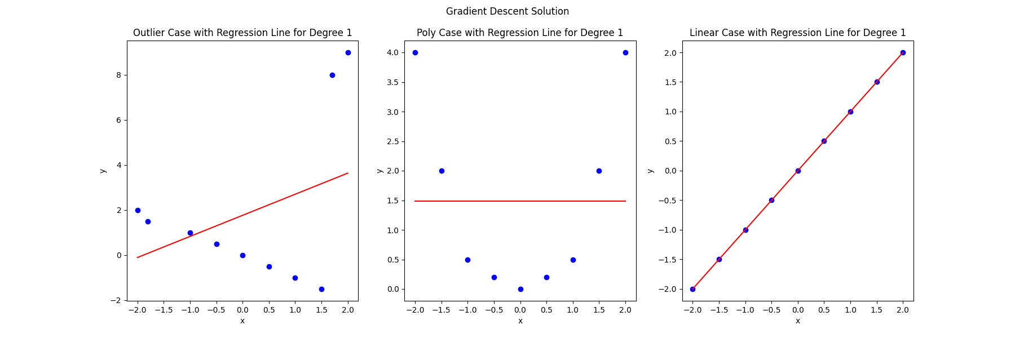

Figure : Linear regression with gradient descent

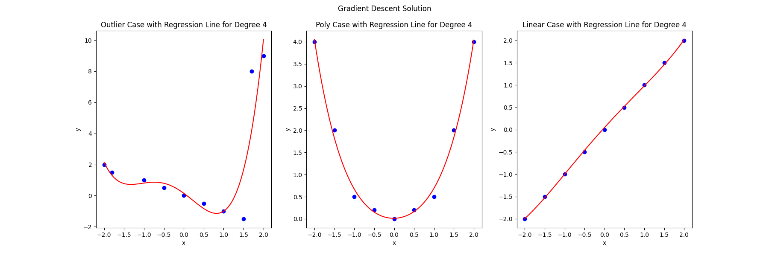

Figure : Fourth order regression with gradient descent

The expected absolute error for the Outlier data using gradient_descent is 0.8991

The expected absolute error for the Poly data using gradient_descent is 0.0964

The expected absolute error for the Linear data using gradient_descent is 0.0511

It seems like gradient descent

Question 3)

$$H=healthy, S=sick, N=negative, P=positive$$

$$P\left(S\right)=0.02, P\left(H\right)=0.98$$

$$P\left(P | S\right)=0.9$$

$$P\left(N | H\right)=0.9, P\left(P | H\right)=0.1$$

To find probability of being sick given the test is positive we expand using bayes formula

$$P\left(S | P\right)=\frac{P\left(P | S\right) x P\left(S\right)}{P(P)}=\frac{P\left(P | S\right) x P\left(S\right)}{P\left(P | S\right) x P\left(S\right)+P\left(P | H\right) x P\left(H\right)}= \frac{0.9 x 0.02}{0.9 x 0.02+0.1 x 0.98}=0.1552$$

Therefore, the test is approximately 155 times accurate out of 1000 times. I would not trust the test out of a single positive and try to redo it until we approach an acceptable probability.

Question 4)

Given the probabilities and utility matrix, expected utility for each class $c_{pred}$ can be calculated with

$$E\left[U\left(c_{pred} | x\right)\right]=\sum_{c_{true}=1}^{\#classes = 3}{p\left(c_{true} | x\right) x U\left(c_{true},c_{pred}\right)}$$

$$E\left[U\left(1 | x\right)\right]=p\left(c=1 | x\right) x U\left(1, 1\right)+ p\left(c=2 | x\right) x U\left(2, 1\right)+ p\left(c=3 | x\right) x U\left(3, 1\right)=0.7 x 5+0.2 x 0+0.1 x\left(-3\right)=3.2$$

$$E\left[U\left(2 | x\right)\right]=p\left(c=2 | x\right) x U\left(1, 2\right)+ p\left(c=2 | x\right) x U\left(2, 2\right)+ p\left(c=3 | x\right) x U\left(3, 2\right)=0.7 x 3+0.2 x 4+0.1 x 0=2.9$$

$$E\left[U\left(3 | x\right)\right]=p\left(c=1 | x\right) x U\left(1, 3\right)+ p\left(c=2 | x\right) x U\left(2, 3\right)+ p\left(c=3 | x\right) x U\left(3, 3\right)=0.7 x 1+0.2 x \left(-2\right)+0.1 x 10=1.3$$

Based on this, selecting $c_{pred}=1$ makes the most sense.

Question 5)

a)

For a random variable x, which has Laplace distribution, $p\left(x\right)=\frac{1}{2}exp⁡(-\left|x\right|)$

Laplace distribution can be seen in Figure 5.

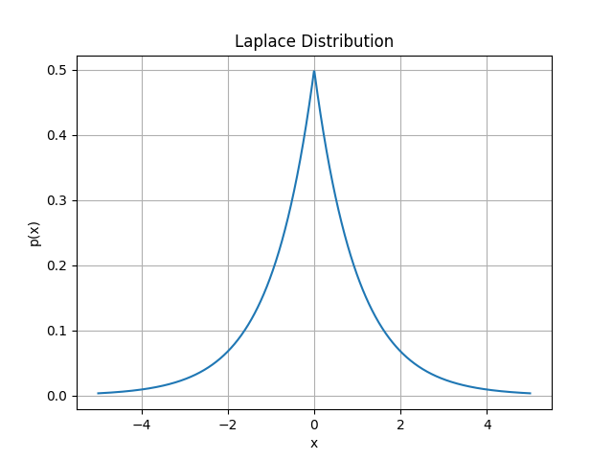

Figure : Laplace distribution

The probability that $x>2$ can be calculated with integrating $p(x)$ from 2 to $∞$, that is since x > 0,

$$p\left(x\right)=\frac{1}{2}exp⁡(-x)$$

$$\int_{2}^{∞}{p(x)dx}=0+\frac{1}{2}\exp\left(-2\right)≅0.6767$$

b)

For a random variable x, which has binomial distribution, $p\left(x\right)=\left(\begin{matrix}n \\ x\end{matrix}\right)p^{x}{\left(1-p\right)}^{n-x}$

$$E\left[x\right]=\sum_{x=0}^{n}{x\left(\begin{matrix}n \\ x\end{matrix}\right)p^{x}{\left(1-p\right)}^{n-x}}$$

$$=\sum_{x=1}^{n}{x\left(\begin{matrix}n \\ x\end{matrix}\right)p^{x}{\left(1-p\right)}^{n-x}}$$

$$=\sum_{x=1}^{n}{n\left(\begin{matrix}n-1 \\ x-1\end{matrix}\right)p^{x}{\left(1-p\right)}^{n-x}}$$

$$=np\sum_{x=1}^{n}{\left(\begin{matrix}n-1 \\ x-1\end{matrix}\right)p^{x-1}{\left(1-p\right)}^{(n-1)-(x-1)}}$$

$$=np\sum_{j=0}^{m}{\left(\begin{matrix}m \\ j\end{matrix}\right)p^{j-1}{\left(1-p\right)}^{m-j}}$$

$$=np$$

$$E\left[x^{2}\right]=\sum_{x=0}^{n}{x^{2}\left(\begin{matrix}n \\ x\end{matrix}\right)p^{x}{\left(1-p\right)}^{n-x}}$$

$$=\sum_{x=0}^{n}{nx\left(\begin{matrix}n-1 \\ x-1\end{matrix}\right)p^{x}{\left(1-p\right)}^{n-x}}$$

$$=np\sum_{x=1}^{n}{x\left(\begin{matrix}n-1 \\ x-1\end{matrix}\right)p^{x-1}{\left(1-p\right)}^{(n-1)-(x-1)}}$$

$$=np\sum_{j=0}^{n}{\left(j+1\right)\left(\begin{matrix}m \\ j\end{matrix}\right){ p^{j}\left(1-p\right)}^{m-j}}$$

$$=np\left(\sum_{j=0}^{n}{j\left(\begin{matrix}m \\ j\end{matrix}\right){ p^{j}\left(1-p\right)}^{m-j}}+\sum_{j=0}^{n}{\left(\begin{matrix}m \\ j\end{matrix}\right){ p^{j}\left(1-p\right)}^{m-j}}\right)$$

$$=np\left((n-1)p\sum_{j=1}^{n}{\left(\begin{matrix}m-1 \\ j-1\end{matrix}\right){ p^{j-1}\left(1-p\right)}^{(m-1)-(j-1)}}+\sum_{j=0}^{n}{\left(\begin{matrix}m \\ j\end{matrix}\right){ p^{j}\left(1-p\right)}^{m-j}}\right)$$

$$=np\left(\left(n-1\right)p+1\right)$$

$$=n^{2}p^{2}+np(1-p)$$

**İbrahim Halil Bayzan**

**504221559**

# Appendix for Q2 and Q5

|  |
| --- |
| # Question 2  import numpy as np  import matplotlib.pyplot as plt  # This is a helper function to create a design matrix for polynomial regression  def design_matrix(x, degree):      X = np.ones((len(x), 1))      for i in range(1, degree + 1):          X = np.hstack((X, np.power(x, i).reshape(-1, 1)))      return X  # Closed-form solution to find the coefficients of the polynomial regression  def polynomial_regression_closed_form(x, y, degree):      X = design_matrix(x, degree)      coeffs = np.linalg.inv(X.T @ X) @ X.T @ y      return coeffs  # Gradient Descent Algorithm  def gradient_descent(X, y, learning_rate, iterations, degree):      m = len(y)      theta = np.random.randn(degree + 1, 1)  # random initialization of parameters      for iteration in range(iterations):          gradients = 2/m * X.T @ (X @ theta - y)          theta = theta - learning_rate * gradients      return theta  def calculate_expected_absolute_error(X, y, theta, verbose=False, method='closed_form', data_name='', degree=None):      y_pred = X @ theta      error = np.abs(y_pred - y).mean()      if verbose:          if degree is not None:              print(f'The expected absolute error for the {data_name} data using {method} and degree {degree} is {error:.4f}')          else:              print(f'The expected absolute error for the {data_name} data using {method} is {error:.4f}')      return error  def plot_data(x, y, coeffs, title, suptitle, degree):      for i in range(len(x)):          plt.subplot(1, len(x), i + 1)          plt.scatter(x[i], y[i], color='blue')          x_values = np.linspace(-2, 2, 1000)          y_values = np.polyval(coeffs[i][::-1], x_values)          plt.plot(x_values, y_values, color='red')          plt.title(title[i] + ' Case with Regression Line for Degree ' + str(degree))          plt.xlabel('x')          plt.ylabel('y')      plt.suptitle(suptitle)      plt.show()  x_example = [None] * 3  y_example = [None] * 3  # Data for the 'outlier' case  x_example[0] = np.array([-2, -1.8, -1, -0.5, 0, 0.5, 1, 1.5, 1.7, 2])  y_example[0] = np.array([2, 1.5, 1, 0.5, 0, -0.5, -1, -1.5, 8, 9])  # Data for the 'Poly' (polynomial) case  x_example[1] = np.array([-2, -1.5, -1, -0.5, 0, 0.5, 1, 1.5, 2])  y_example[1] = np.array([4, 2, 0.5, 0.2, 0, 0.2, 0.5, 2, 4])  # Data for the 'Linear' case  x_example[2] = np.array([-2, -1.5, -1, -0.5, 0, 0.5, 1, 1.5, 2])  y_example[2] = np.array([-2, -1.5, -1, -0.5, 0, 0.5, 1, 1.5, 2])  # Map of data names to their respective indices  data_names = {0: 'Outlier', 1: 'Poly', 2: 'Linear'}  degree = 4  coeffs_closed_form = [None] * 3  for i in range(3):      coeffs_closed_form[i] = polynomial_regression_closed_form(x_example[i], y_example[i], degree)  # Now set up the gradient descent parameters  learning_rate = 0.01  iterations = 1000  # Prepare the design matrix for gradient descent  X_design = [None] * 3  theta_gradient_descent = [None] * 3  for i in range(3):      X_design[i] = design_matrix(x_example[i], degree)      theta_gradient_descent[i] = gradient_descent(X_design[i], y_example[i].reshape(-1, 1), learning_rate, iterations, degree)  # Calculate expected absolute error for both models  error_closed_form = [None] * 3  error_gradient_descent = [None] * 3  # print('Expected Absolute Errors:' + ' for degree ' + str(degree))  for i in range(3):      error_closed_form[i] = calculate_expected_absolute_error(X_design[i], y_example[i].reshape(-1, 1), coeffs_closed_form[i], True, 'closed_form', data_names[i], degree)      error_gradient_descent[i] = calculate_expected_absolute_error(X_design[i], y_example[i].reshape(-1, 1), theta_gradient_descent[i], True, 'gradient_descent', data_names[i])  # Plot for the 'Outlier' case  plt.figure(figsize=(18, 6))  plot_data(x_example, y_example, coeffs_closed_form, data_names, 'Closed Form Solution', degree)  # Plot the gradient descent solution along with the data points in a 3 x 1 subplot  plt.figure(figsize=(18, 6))  plot_data(x_example, y_example, theta_gradient_descent, data_names, 'Gradient Descent Solution', degree) |
| # Question 5  import numpy as np  import matplotlib.pyplot as plt  from scipy.integrate import quad  def laplace_distribution(x):      return 0.5 * np.exp(-np.abs(x))  x_values = np.linspace(-5, 5, 1000)  y_values = laplace_distribution(x_values)  plt.plot(x_values, y_values)  plt.xlabel('x')  plt.ylabel('p(x)')  plt.title('Laplace Distribution')  plt.grid(True)  plt.show()  prob_x_gt_2 = quad(laplace_distribution, 2, np.inf)  print('The probability that x > 2 is', prob_x_gt_2[0]) |